Mean Global Temperature Anomaly (figure 1)

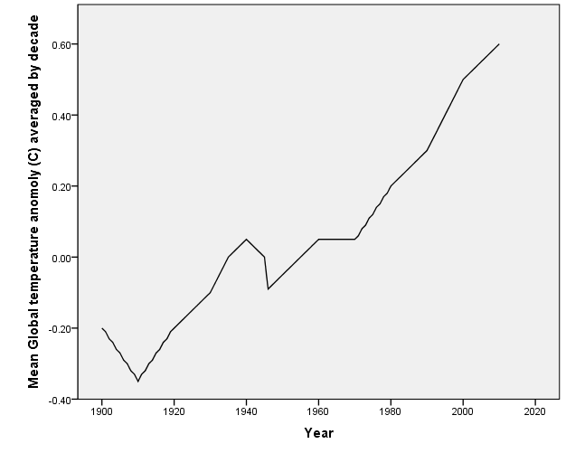

Global Population (figure 2)

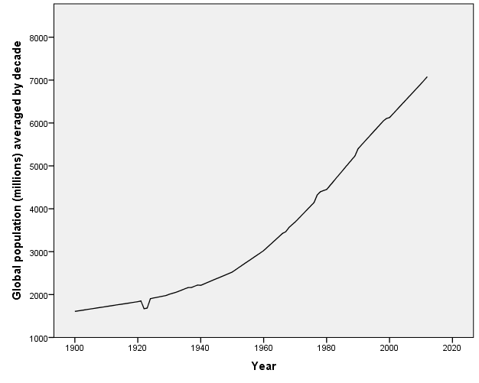

Global Sea Level (figure 3)

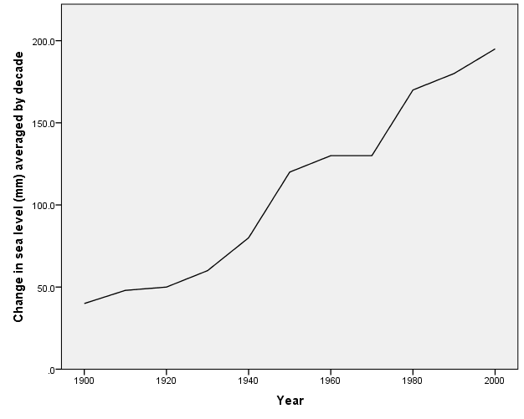

Arctic Sea Ice (figure 4)

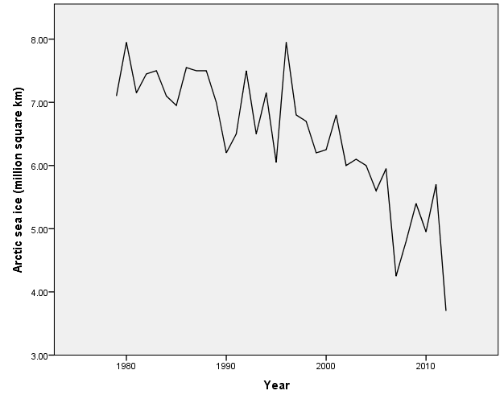

Size of Antarctic Ozone Hole (figure 5)

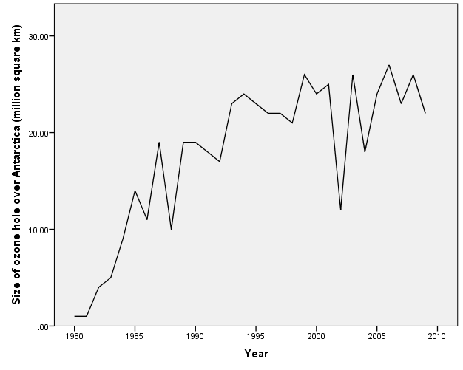

Global CO2 Emissions (figure 6)

